**ONLINE FOOD ORDER SYSTEM FOR RESTAURANTS**

Abstract

ONLINE FOOD ORDER SYSTEM is a website designed primarily for use in the food delivery

industry. This system will allow hotels and restaurants to increase scope of business by reducing the labor cost involved. The system also allows to quickly and easily manage an online menu which customers can browse and use to place orders with just few clicks. Restaurant employees then use these orders through an easy to navigate graphical interface for efficient processing.

Introduction

It is known globally that, in today’s market, it is extremely difficult to start a new small-scale business and live-through the competition from the well-established and settled owners. In fast paced time of today, when everyone is squeezed for time, the majority of people are finicky when it comes to placing a food order. The customers of today are not only attracted because placing an order online is very convenient but also because they have visibility into the items offered, price and extremely simplified navigation for the order.

Online ordering system that I am proposing here, greatly simplifies the ordering process for both the customer and the restaurant. System presents an interactive and up-to-date menu with all available options in an easy-to-use manner. Customer can choose one or more items to place an order which will land in the Cart. Customer can view all the order details in the cart before checking out. At the end, customer gets order confirmation details. Once the order is placed it is entered in the database and retrieved in pretty much real time. This allows Restaurant Employees to quickly go through the orders as they are received and process all orders efficiently and effectively with minimal delays and confusion.

Motivation

The motivation for designing this application came because my family is involved in the fast food business and I personally do not like waiting for long in the store or to have to call store to place an order especially during the peak lunch or dinner hours. Moreover, I value recent learning about the Java and JSP Programming languages as well as seeing how powerful and dynamic they are when it comes to web designing and applications. The languages used to build this application are JavaScript, JSP, HTML and Java at client facing whereas Oracle database at the back-end because I found them to be extremely useful while working on the technologies.

Aim of the Software

This software is developed to help computer science students to learn about the Web application designing using JSP and HTML from their basic capabilities to build a complete working application from scratch. Further, it gives insight about how GUI interacts with server-side language, Java, and finally with the Oracle database.

Background and Related Work

This Case study looks at the problem of setting up a fast-food restaurant. In existing system there are few problems:

For placing any orders customers have to visit hotels or restaurants to know about food items and then place order and pay. In this method time and manual work is required.

While placing an order over the phone, customer lacks the physical copy of the menu item, lack of visual confirmation that the order was placed correctly.

Every restaurant needs certain employees to take the order over phone or in-person, to offer a rich dining experience and process the payment. In today’s market, labor rates are increasing day by day making it difficult to find employees when needed.

Hence, to solve this issue, what I propose is an “Online Food Order System, originally designed for small-scale business-like College Cafeterias, Fast Food restaurant or Take-Out, but this system is just as applicable in any food delivery industry.

The main advantage of my system is that it greatly simplifies the ordering process for both the customer and the restaurant and also greatly lightens the load on the restaurant’s end, as the entire process of taking orders is automated.

Anticipated Benefits are:

This will minimize the number of employees at the back of the counter.

The system will help to reduce labor cost involved.

The system will be less probable to make mistake, since it’s a machine.

This will avoid long queues at the counter due to the speed of execution and number of optimum screens to accommodate the maximum throughput.

Program Requirements

Outline your solution. Describe the "whats" of your project -- what does it do?

Product Perspective:

The Online Food Order System application is a web-based system. It can be accessed using IE 10.0 and above, Fire Fox 31 and above and Google Chrome.

System Model:

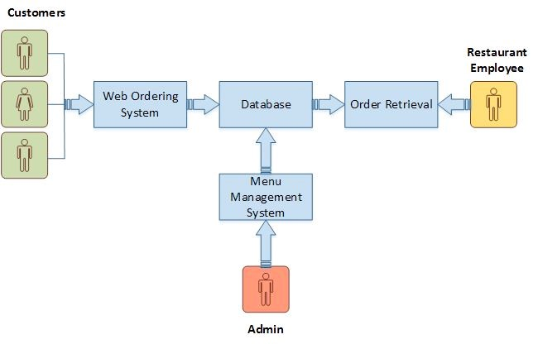

Figure 1

The structure of the system can be divided into 3 main logical components:

Web Ordering System- provides the functionality for customers to place their order and supply necessary details.

Menu Management-allows the restaurant to control what can be ordered by the customers

Order Retrieval System-This is a final logical component. Allows restaurant to keep track of all orders placed. This component takes care of order retrieving and displaying order information.

Product Function:

The Online Food Order System application would have the following basic functions:

Web Ordering System Module

This module provides the functionality for customers to place their order and supply necessary details. Users of the system, namely restaurant customers, must be provided the following functionality:

Create an account.

Manage their account.

Log in to the system.

Navigate the restaurant’s menu.

Select an item from the menu.

Add an item to their current order.

Review their current order.

Remove an item/remove all items from their current order.

Provide payment details.

Place an order.

Receive confirmation in the form of an order number.

View order placed.

Additional Feature:

eClub- Allows user to subscribe to eClub to get promotional deals and discounts offers.

Out of all the functions outlined above, Account Creation and Management only will be used

every time a customer places an order. This will allow to simplify the overall user experience.

Menu Management System Module

This module provides functionality for the power user-Administrator only. It will not be available to any other users of the system like Restaurant Employees or Customers.

Using a graphical interface, it will allow an Admin to manage the menu that is displayed to users of the web ordering system:

Add/update/delete food category to/from the menu.

Add /update/delete food item to/from the menu.

Update price for a given food item.

Update additional information (description, photo, etc.) for a given food item.

Before customers can actually use this system, functionality provided by this component will have to be configured first. Once the initial configuration is done, this will be the least likely used component as menu updates are mostly seasonal and do not occur frequently.

Order Retrieval System Module

This is the most simplest module out of all 3 modules. It is designed to be used only by restaurant employees, and provides the following functions:

Retrieve new orders from the database.

Display the orders in an easily readable, graphical way.

Implementation

Hardware/Software Interface:

This section lists the minimum hardware and software requirements needed to run the system efficiently.

Hardware Interface:

i5

10GB

8 GB of RAM

Software Interface:

Operating System: Windows (10 or 11)

Web Browser: EDGE or above, Mozilla FF or Google Chrome

Drivers: Java Runtime Environment

Integrated Development Environment: Eclipse J2EE andApache Tomcat

Technology :

Spring Boot ,

Spring MVC

Spring Rest API

JPA

Security

Postgre or MySQL

Functional Requirement Specifications:

Activity Diagram:

This section lists the activity diagram and describes the flow of the activities in the system. A detailed description is then given after the figure for each activity. Figure 2 provides the overview of the activity of the Online Food Order System application.

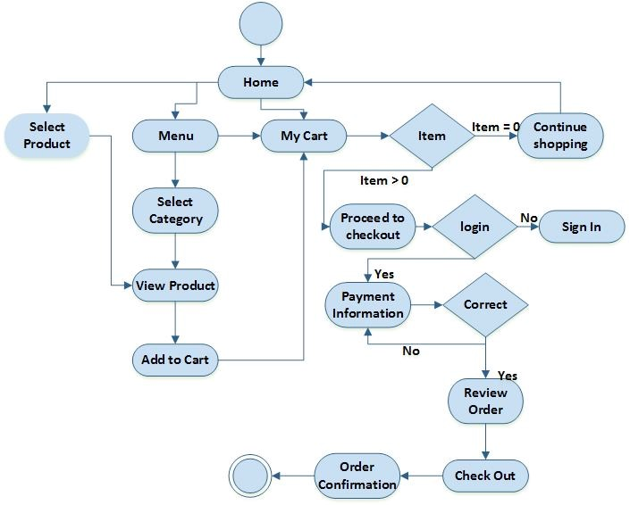

Figure 2

All users of the system, are provided with below menu options:

Home, Menu, My Cart, UserAccount, eClub, AboutUs and Contact

Web Ordering System Module

Customers of the Web Ordering system will interact with the application through an easy to use top navigation menu.

“Home” menu option: allows the users to see all food items offered with nice images as well as select an item to place an order.

“Menu”menu option: a ‘Drop-Down’ menu, allows users to see all food items per category. Item can then be added to the cart using a single button click.

“My Cart (x)”menu option:

Allows users to see details of the items placed in cart. Details include Item #, Product Name, Product Image, Product Description, Quantity, Unit Price, Total per item and final Total of the order. It also allows ‘Update’ and ‘Delete’ an item using single button click. User can then use a ‘Proceed to checkout’ button to proceed further.

Once, Check Out button is selected, user will be prompted for the Sign In/Sign Up process if not logged in else user will be presented with a simple “Payment Information” form. User will be asked to provide all required details in displayed text boxes and make appropriate Dropdown selections. Then, all this information can be saved using a ‘Save’ button.

User will then be presented with a “Review Order” page, which will display Payment Information along with Order details to review. User can then use a ‘Check Out’ button to place an order.

Once order is placed, user will be presented with appropriate Order confirmation success/failure message.

“MyAccount”: a “Drop Down” menu will display the user orders, Sign In and Sign Out options.

eClub- Allows user to subscribe to eClub to get promotional deals and discounts offers.

Menu Management System Module

Similar to Web ordering system, this module presents Admin with below additional options under “MyAccount” Drop down menu:

Add Category: Allows to add a food Category name in a simple form.

Add Product: Allows to add Product Name, Description, Price and choose Category in a simple form along with Product Image.

Modify Product: Allows updating or deleting product details.

Order Retrieval System Module

The application will automatically fetch new orders from the database at regular intervals and display the order numbers.

Under “MyAcoount’ menu a customer will be able to see only his/her order whereas a Restaurant Employee or an Admin can see all users’ orders.

To view the details of an order, the user must click on that order number, which will display all order details This structure can intuitively be expanded and collapsed to display only the desired information.

Non-functional Requirements

All of the application data is stored in a Oracle database, and therefore a Oracle Database must also be installed on the host computer. As with Apache2, this software is freely available and can be installed and run under most operating systems.

The server hardware can be any computer capable of running both the web and database servers and handling the expected traffic. For a small-scale restaurant that is not expecting to see much web traffic, an average personal computer may be appropriate. Once the site starts generating more hits, though, it will likely be necessary to upgrade to a dedicated host to ensure proper performance. The exact cutoffs will need to be determined through a more thorough stress testing of the system.

Constraints

Hardware Limitations: The minimum hardware requirement for the system is 128 MB of Ram and a 60MB hard-disc drive.

Others: The application should be built using Java and JavaScript inscribed in HTML, and it should, initially, be accessible through the eclipse IDE and later published on a server

System Evolution

The heart of the entire ordering system is the Database. Currently the system is only available for small scale restaurants. For Large restaurants, performance considerations should be taken into account in terms of Hardware/Software capacity/Page load time etc. Also, security vulnerabilities should be evaluated for large scale systems.

In future this can also be available as a Mobile application and can be integrated with in store Touch Screen Order devices.

I am also certain that if this system goes into actual use, many requests will arise for additional features which I had not previously considered, but would be useful to have. For this reason, I feel as though the application can be constantly evolving, which I consider a very good thing.

Appendices

This section includes figures for ER Diagram and various Web application images.

ER Diagram:

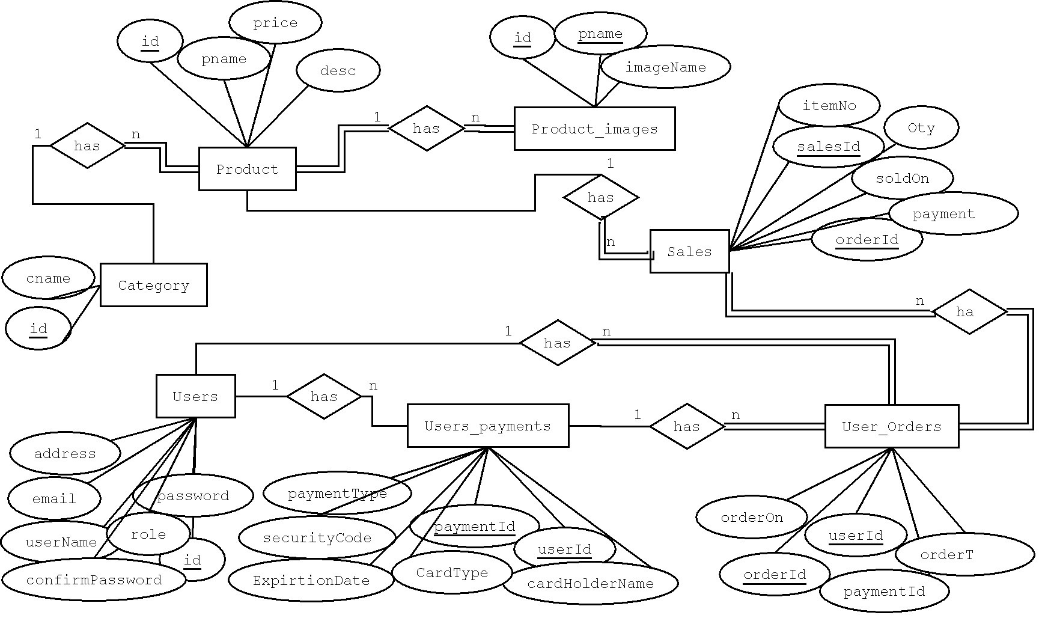

Web Application images:

Fig A: Sign In

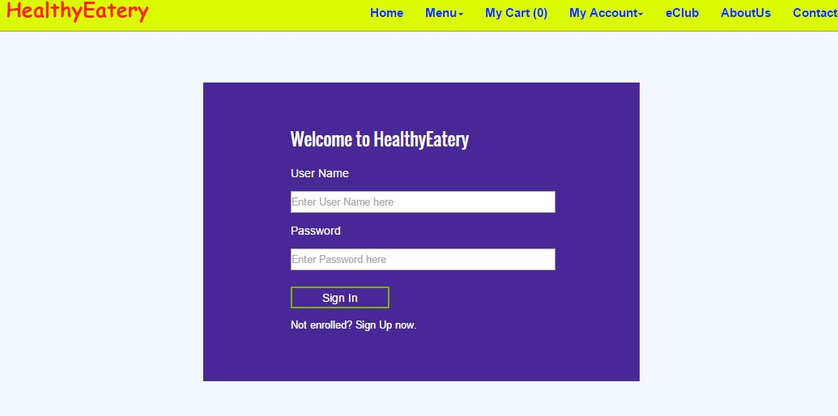

Fig B: Home page

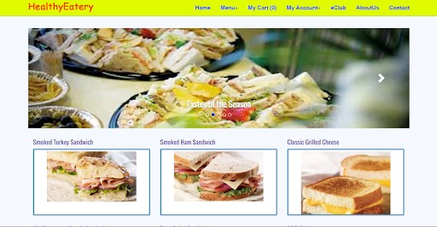

Fig C: Menu Section



Fig D: “Sandwich” Menu Selection Page

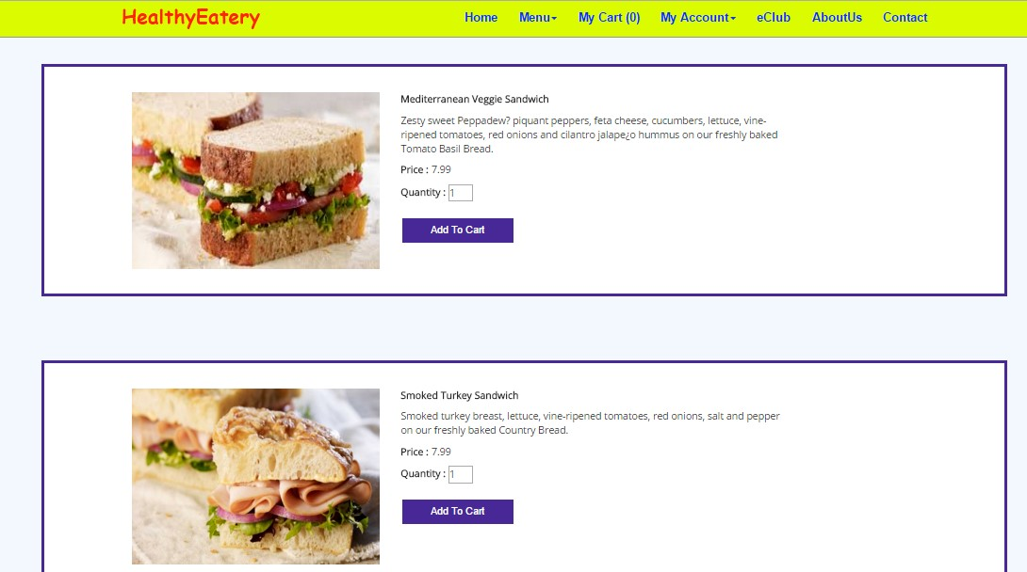

Fig E: My Cart

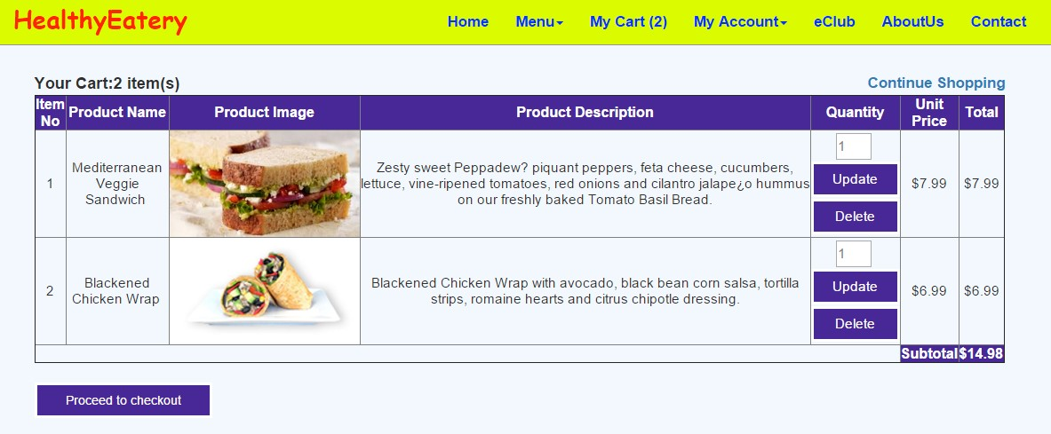

Fig F: Payment Confirmation

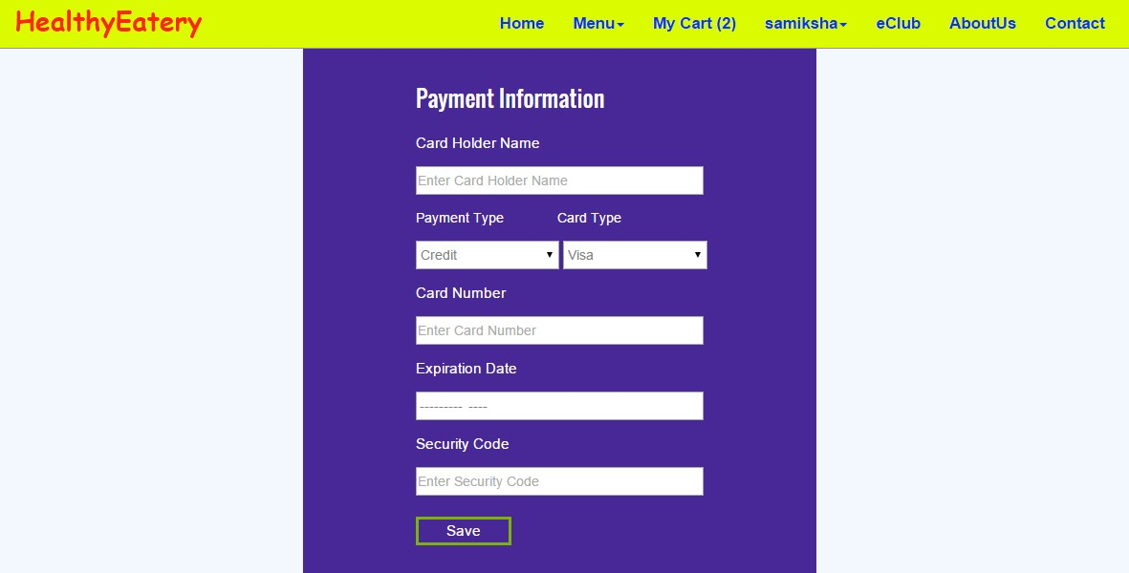

Fig G: Review Order

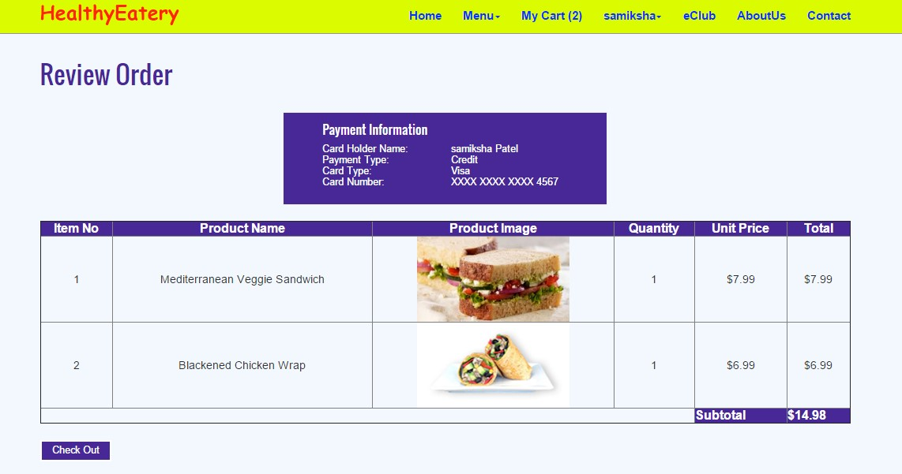

Fig H: Order Confirmation

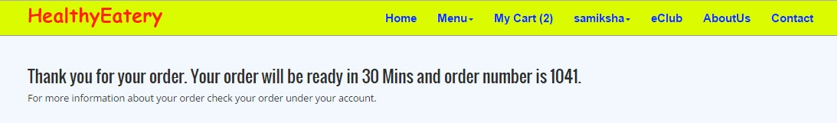

Fig I: My Account menu as an “Administrator”

